DATA set:

<https://www.kaggle.com/theforcecoder/wind-power-forecasting>

Example:

<https://www.kaggle.com/zhangwei0720/predict-windspeed-by-regression>

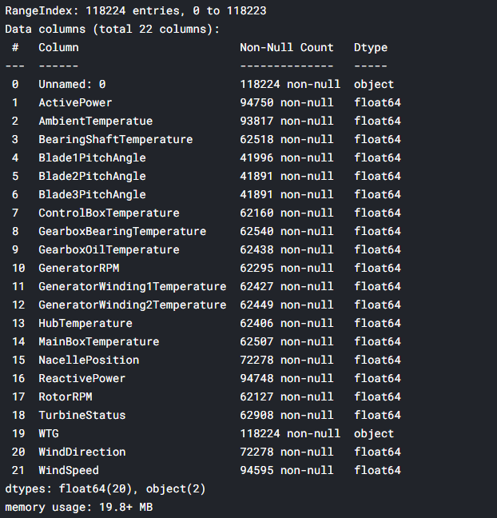

Label: WindSpeed

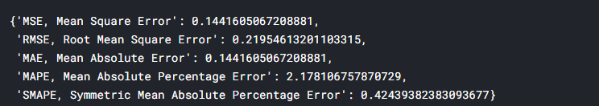

Linear Regression Result